**CTF Challenge: Email Security**



**Email Security?**

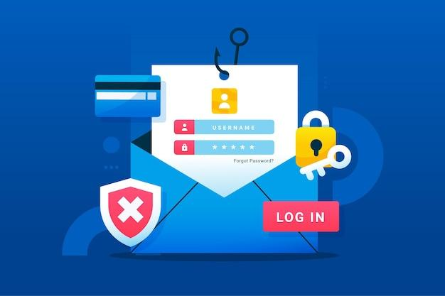

Email security aims to safeguard the transmission and storage of email messages to prevent unauthorized access, data breaches, and malicious activities. It encompasses both technical solutions and user awareness practices to ensure that emails remain secure throughout their lifecycle.

### **Common Threats to Email Security:**

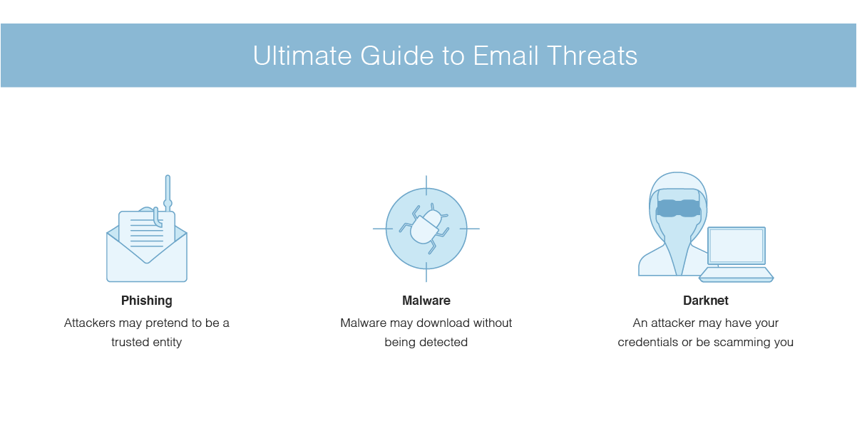

1. **Phishing**: Deceptive emails designed to trick recipients into divulging sensitive information, such as passwords or financial details, or clicking on malicious links.
2. **Malware Attachments**: Emails containing attachments that, when opened, execute malicious code on the recipient’s device, potentially leading to data loss or system compromise.
3. **Spam**: Unsolicited bulk emails, often promoting scams, fraudulent products, or phishing attempts, which can overwhelm email servers and hinder legitimate communication.
4. **Email Spoofing**: Forging email headers to make messages appear as if they are from a trusted sender, often used in phishing or spam campaigns.
5. **Man-in-the-Middle Attacks**: Intercepting email communications in transit to eavesdrop on or modify messages exchanged between sender and recipient.
6. **Data Leakage**: Unauthorized disclosure of sensitive information through email due to misaddressing, accidental forwarding, or intentional leaks.

### **Techniques and Solutions for Email Security:**

1. **Authentication Protocols**:

* **SPF (Sender Policy Framework)**, **DKIM (DomainKeys Identified Mail)**, and **DMARC (Domain-based Message Authentication, Reporting & Conformance)**: These protocols verify the authenticity of email senders and help prevent spoofing and phishing attacks.

1. **Secure Email Gateways (SEGs)**:

* Acts as a perimeter defense by filtering inbound and outbound email traffic, scanning for threats, enforcing policies, and blocking malicious content.

# **Capture the Flag (CTF) Challenges**

**Flag 1. What does SPF stand for in email security?**

Answer: Sender PolicyFramework

**Flag 2. Which protocol verifies the authenticity of email senders?**

Answer: DKIM

**Flag 3. What type of emails overwhelm servers and hinder legitimate communication?**

Answer: Spam

**Flag 4. What does DMARC provide in addition to authentication?**

Answer: Reporting

**Flag 5. What intercepts email communications to eavesdrop or modify messages?**

Answer: MITM